TRABAJO PET

PET B1 NIVEL 1

- SPEAKING PART 2: In this part of the Speaking test, you will talk on your own about a color photograph. The photograph will show and everyday situation.

These are the photographs:

Picture 1:

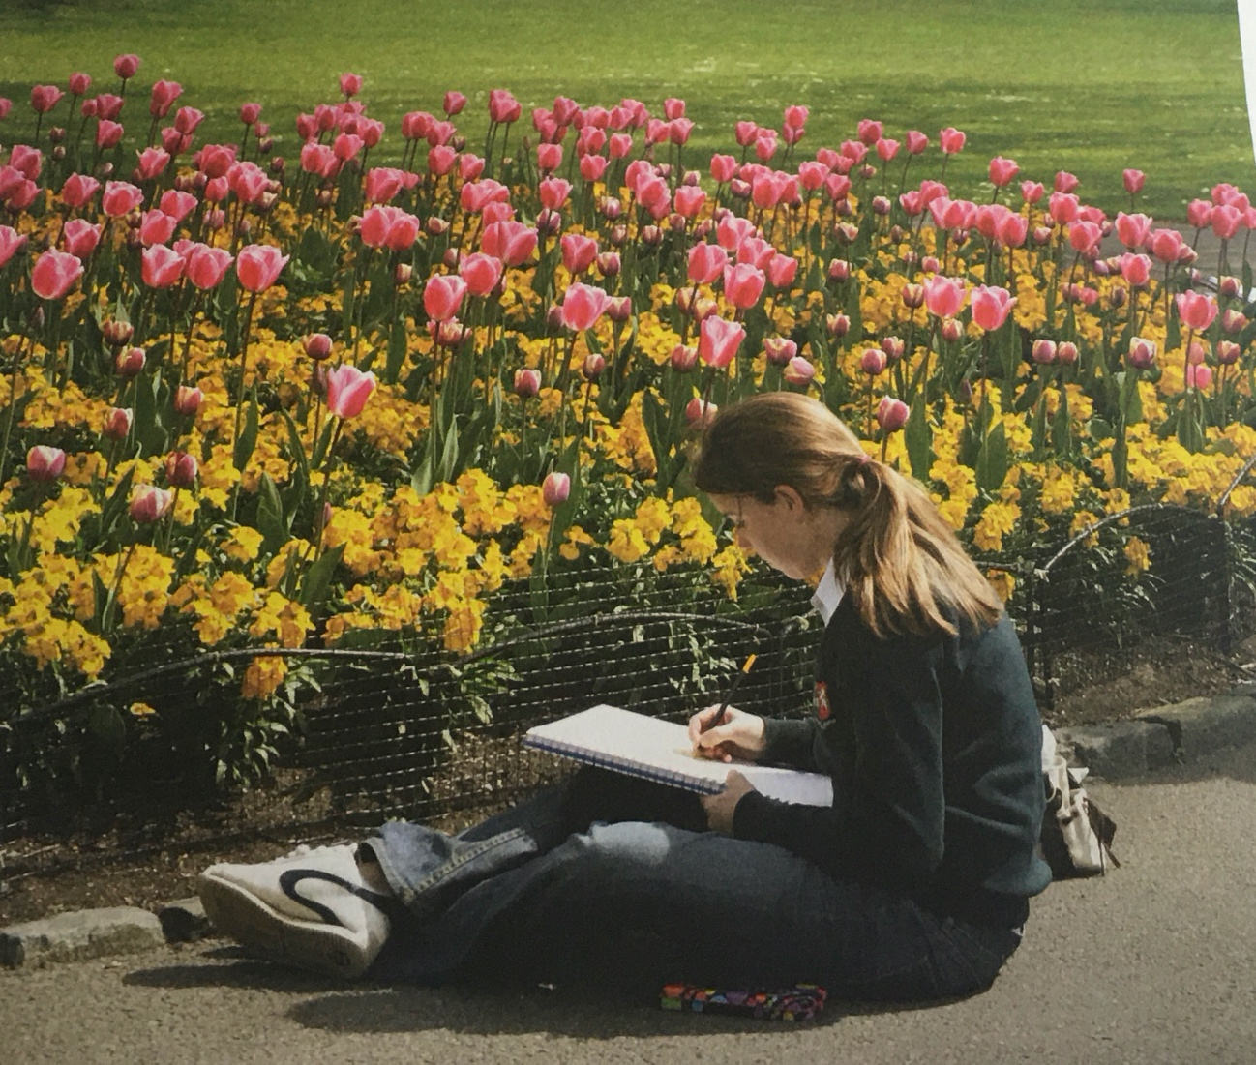

Picture 2:

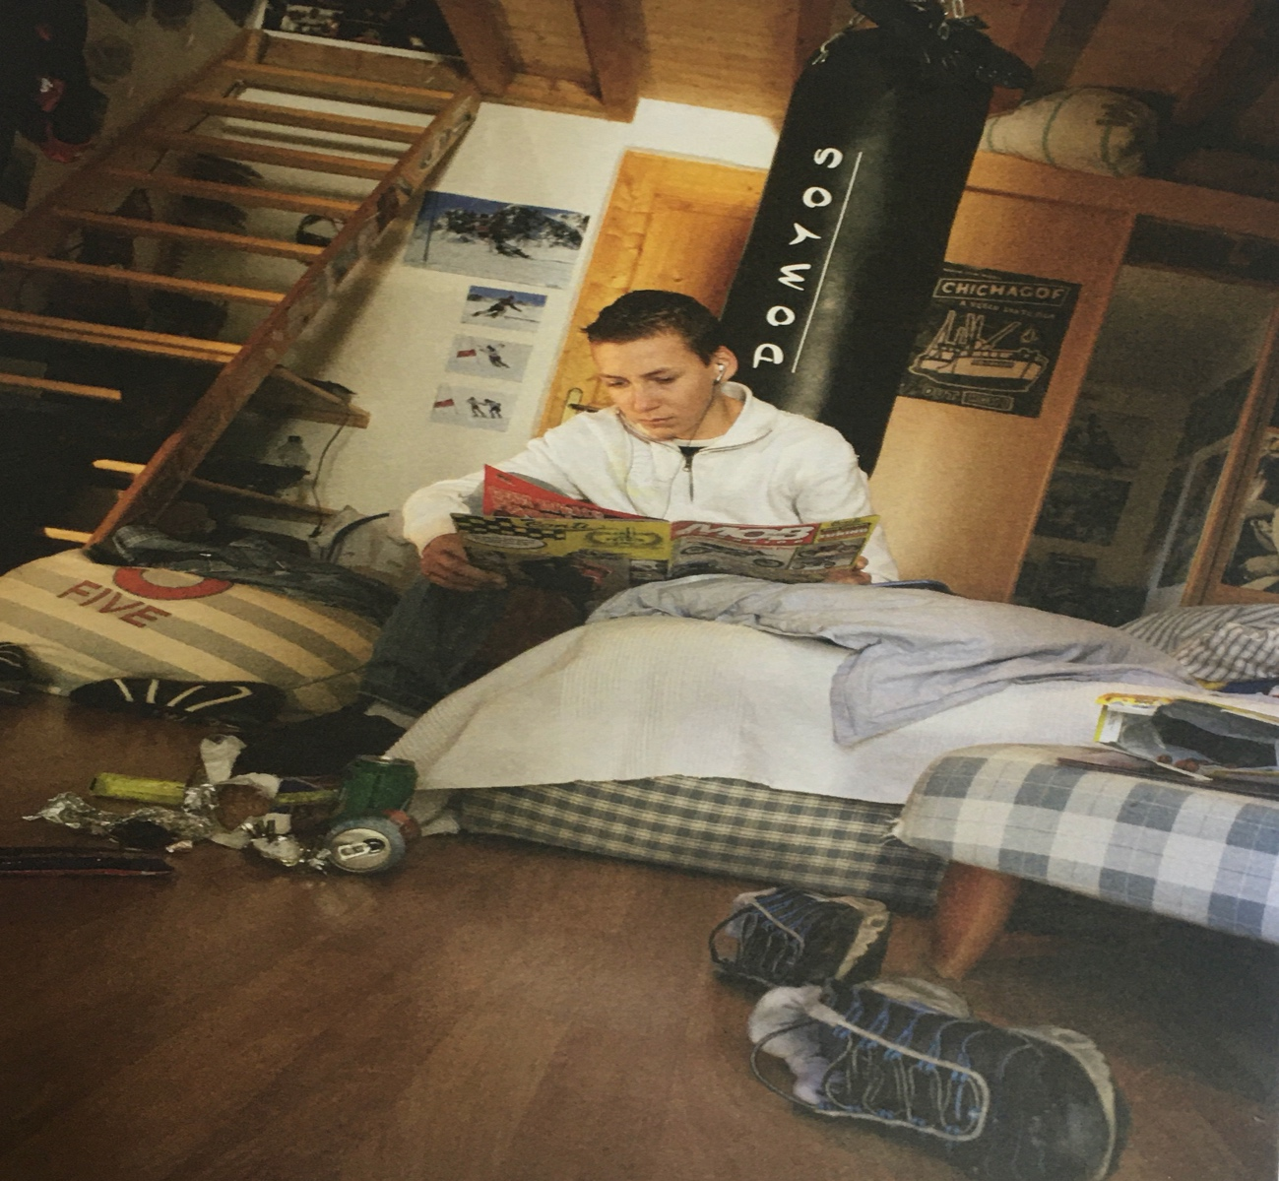

- Warm up:

1.- Match these descriptions with items in Pictures 1 and 2:

- I can´t remember the name of it but we use it to go up or down in a house.
- She´s holding a book that we draw pictures in.
- I don´t remember the name of them but they´re sports shoes.

2.- Now match the objects with their name:

Trainers sketchbook stairs
3.- Make notes in the table for the pictures 1 and 2:

 | PICTURE 1 | PICTURE 2
The place
The people
The action

- Now you are ready to describe what you can see in your photograph (choose
one of them). Keep the description simple.

Talk about the whole photograh first (e.g. This picture shows someone reading in their room.) before you talk about the details.

When talking about the details, talk about the photograph as if you were describing it to someone who can´t see it.

Talk about:
- The place (where it is, the time, the weather, the atmosphere).
- The people (how many, male/female, ages, clothes, mood).
- The action (reading, writing, relaxing, eating, talking, working, studying, drawing, playing).

Use some precise vocabulary when talking about what you can see in the picture. But if you can´t remember the name of an object in the photograph, don´y worry. Describe it or talk about what it might be used for. For example, bookshelves or a bookcase could be described as something we keep books in.

